EXPERIMENT 11
Query with Joins – EquiJoin, InnerJoin, OuterJoin

EQUI JOIN
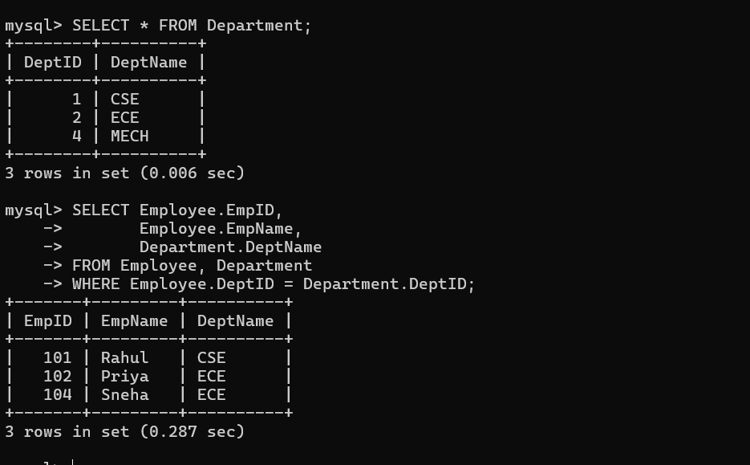

INNER JOIN
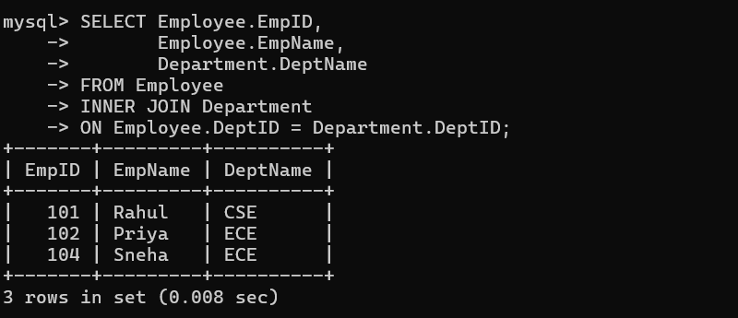

LEFT OUTER JOIN
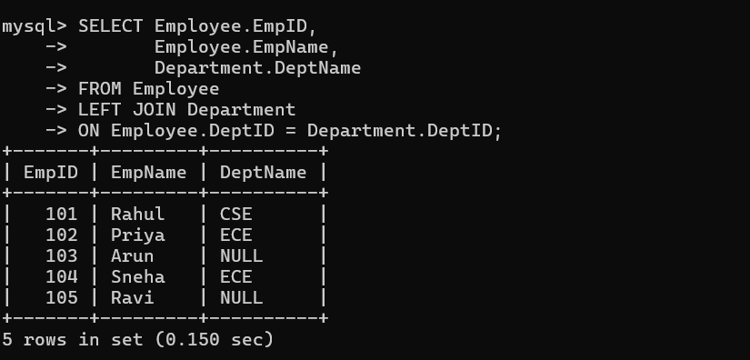

RIGHT OUTER JOIN
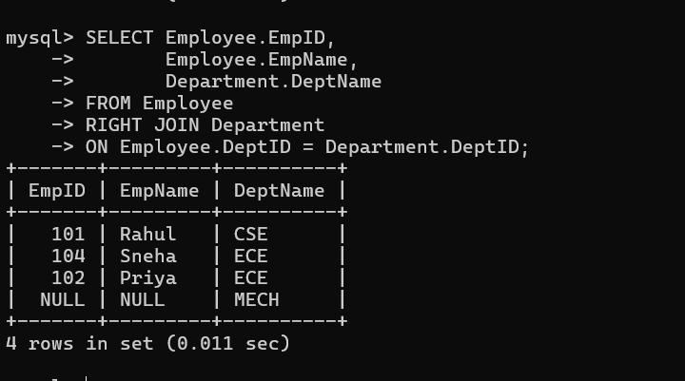

FULL OUTER JOIN
